Pricing Report
14th February 2022

Energy bills are driven by both the price of energy on the wholesale market and Third-Party Costs (TPCs). TPCs include non-energy costs set by the government, network (the National Grid), policy and system costs and electricity transmission/distribution costs.
The biggest single cost on a bill is the price of the energy. The wholesale cost of the energy makes up approximately 40% of an electricity bill and 70% of a gas bill, with the remaining being TPCs, which have been continuously rising in recent years and can be volatile.
This pricing report will focus on the energy element of a bill to help you keep track and understand the wholesale energy market and the factors affecting the price of your contracts.

Overview:
Surging demand and geopolitical tensions continue to create a volatile market for wholesale gas prices. Many suppliers and industry experts do not see any relief until Summer 2024 and that does not consider the current situation with Russia and Ukraine, which if Russia were to invade could cause a catastrophic impact on gas supply and prices even further.

Russia has been accused of deliberately cutting gas supplies to Europe after US President Joe Biden vowed to send troops to Poland and Germany during the Ukraine crisis. This has driven prices even further, reaching record highs again as Europe depends on Russian gas for almost 40% of its natural gas supplies.

Energy regulator, Ofgem, has also announced it is increasing the price cap for millions of domestic customers, to help suppliers to take on new customers and afford the soaring price of wholesale energy. This however does NOT apply to businesses, and we have seen many suppliers already release their new out of contract tariffs which take effect from March, which are all significant increases.

If you are sitting on out of contract rates, unaware that business energy prices are not regulated in the same way as domestic, then you could end up paying up to 500% more for your energy than you need to.

Bullish Factors (upward pressure on markets):
- Geopolitical tensions escalating between Russia and Ukraine
- Reduced gas flows to Europe from Russia
- Surge in energy demand

Bearish Factors (downward pressure on markets):
- Forecasts for increased wind generation
- Healthier LNG flows

Gas and Power
MARKET REPORT
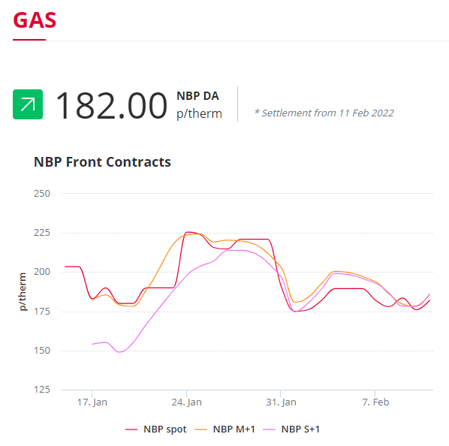
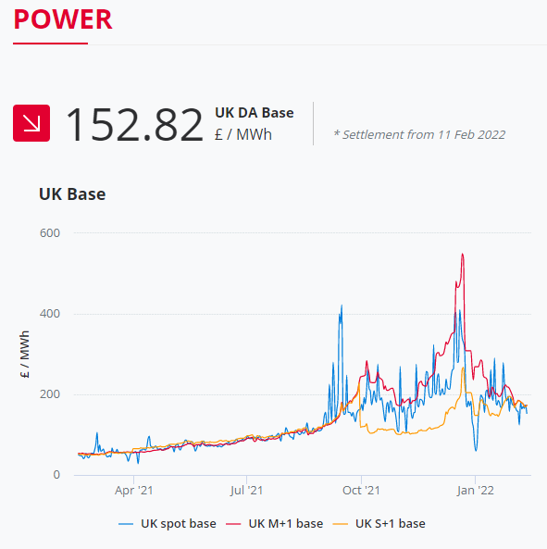
Gas flows into Europe via Ukraine remain very low, lifting contract prices as the supply struggles to meet the demand. LNG flows have been healthier and wind generation has picked up, helping to lift some of the reliance on gas. However, concerns that Russia may invade Ukraine as soon as Wednesday continue to impact markets.

In the graphs, you can see that gas contracts starting now (Spot), those within the month ahead (M+1) and those purchased now for the next season (S+1), are all a similar price. If you are not out of contract until summer and have waited to secure a fixed contract, you will be paying a lot more than if you had locked a rate in back in January where prices were as low as 150p/therm compared to 178p/therm today.

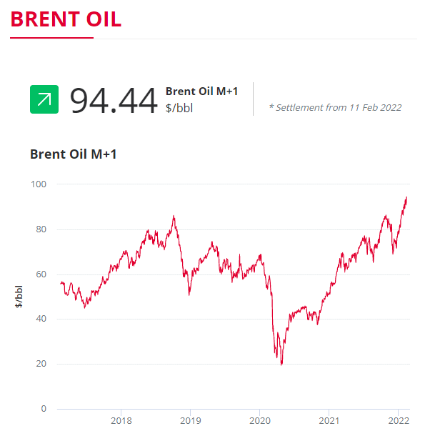
A season in the business energy market is a 6-month spread and these are from April to September for "Summer" and October to March for "Winter".
Crude Oil
Brent crude gained value on Friday following expectations of increased demand as OPEC and the IEA both raised their demand forecasts.
Brent has increased further, fuelled by fears of a Russian invasion of Ukraine which would likely disrupt oil supplies.

Current price standings:
Brent Crude = $94.44/bbl

Businesses are NOT Protected by the New Price Cap
ENERGY NEWS
Energy regulator Ofgem has increased the price cap by £693 a year for over 22 million household customers in April. The price cap on standard and default tariffs is rising by 54%, which is the steepest increase to the price cap since its introduction in January 2019. This is largely due to the record gas prices, which have quadrupled in the last year, that energy suppliers are having to pay to procure the energy to supply to their current and any new customers.

With wholesale gas prices still high and half of the UK's energy suppliers collapsing, many of the remaining suppliers have increased their "deemed rates" even further. These are the rates customers will pay when they fall out of contract.

Martin Lewis has warned that most should continue to do nothing with their energy and should stick with the price cap. However, this ONLY applies to households. The out of contract rates for businesses are not regulated, which means suppliers are able to amend their rates whenever they want and to whatever price they want. This has resulted in many businesses sitting on out of contract rates which can be up to 500% more than they could be paying if they were in a fixed contract.

With the increase in energy prices for both households and businesses, along with the cost of living in general increasing, this will have a large impact on those businesses in the hospitality sector as well. With the costs of food and drink likely to soar as much as 20% coupled with customers having less disposable income to spend, these businesses are likely to be hit even harder.

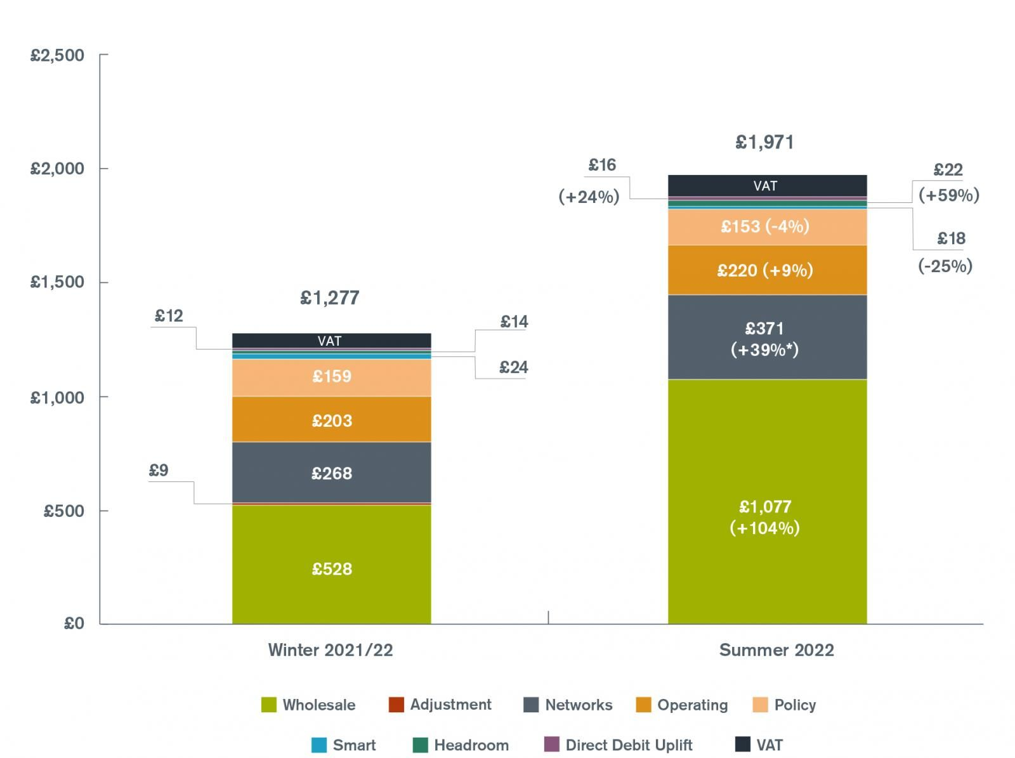
Fixing a contract rate now if you are out of contract or due for renewal within the next 18 months might be worth looking into to ensure you are not paying over the odds for your energy when it can be avoided.

Geopolitical Tensions Impacting Gas Prices
Tensions between Russia and Ukraine continue to escalate, with Russia appearing to stop the supply of gas to Europe by reversing the pipeline that runs from Russia into Germany to show the chaos that Russia is capable of. Restricting the amount of gas that flows from Russia into Europe creates a gas shortage and continues to push wholesale prices to record highs.

Russia has denied the accusations, but it comes after Russian President Vladimir Putin and Hungarian President Viktor Orbán have agreed on a deal for Russia to increase their gas deliveries to Hungary until 2036.

Brandon Weichert, author of Winning Space: How America Remains a Superpower, said: “At a time when most of Europe is starved of affordable natural gas because of the ongoing tensions in Ukraine between the West and Russia, Hungary swooped in and got a deal to purchase large quantities of natural gas from Russia at five times the cheaper rate than what most other Europeans can purchase it for. This is obviously a deeply complicating factor for the wider NATO/EU alliance, as Washington attempts to coordinate a unified strategy for deterring Russian aggression in Eastern Ukraine.”

Every day Europe purchases 40% of its gas from Russia, to meet the daily demand. If Russia were to invade Ukraine, in one way or another gas will be impacted. Either through a temporary outage of supply which if contained might be manageable or a catastrophic continent-wide shutdown.

